# IT 315 Final Project Part III Solution Submission Template

This template is a guide for you to organize your information. To complete it, **replace the bracketed text with the relevant information.** Some areas may be too large or too small for the information you’re inserting. Adjust the size of the areas as necessary.

**Name:** [Joseph Silva Jr.]

**Date:** [02/11/21]

1. Generate your student information system (SIS) sequence diagram for the Register a Student for Classes use case.

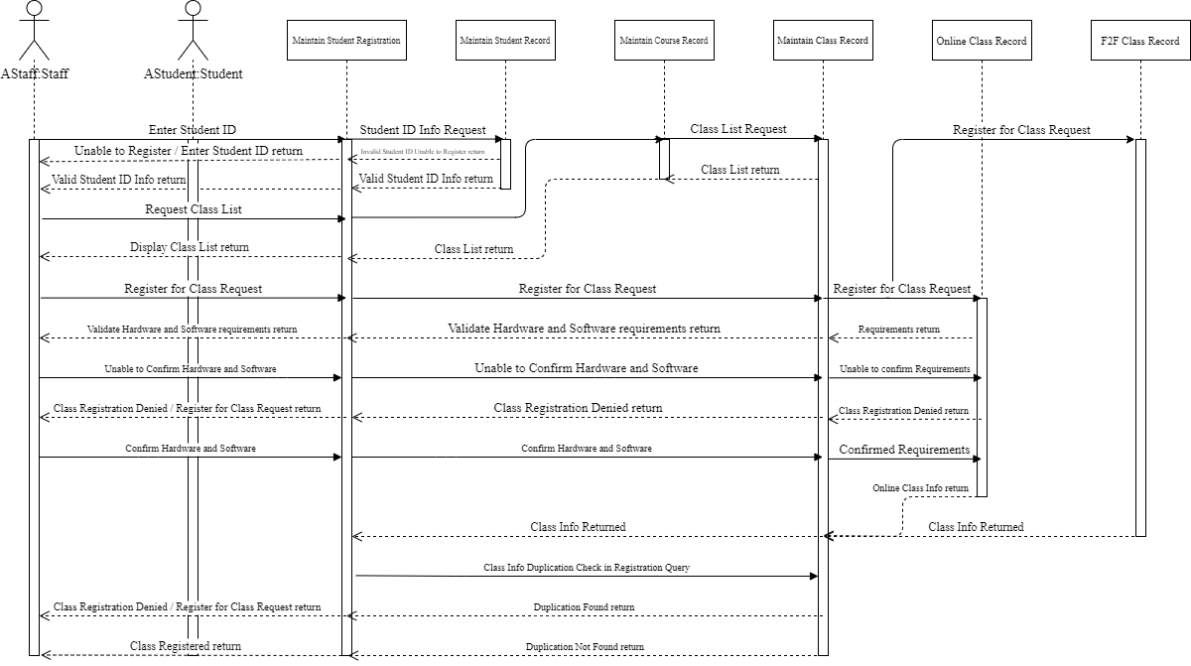

Generate your SIS communication diagram for the Register a Student for Classes use case.

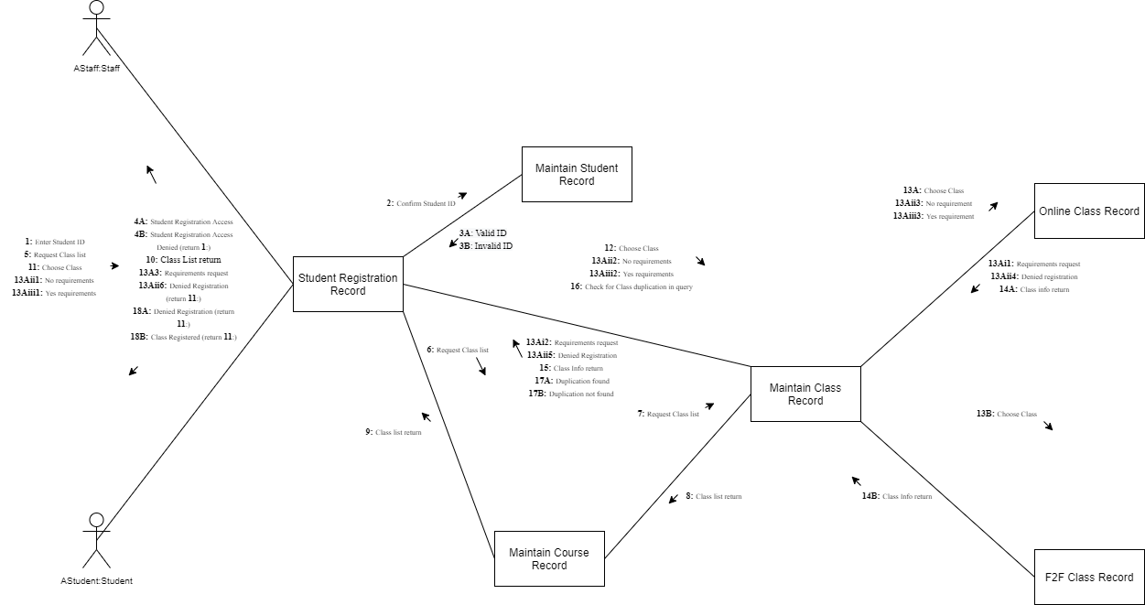

**SIS Method Contract 1 template** (refer to textbook pages 306–314):

|  |  |  |
| --- | --- | --- |
| Method Name:  [confirmStudentID] | Class Name:  [Student Registration Record] | ID:  [1] |
| Clients (Consumers):  [Student Registration] | | |
| Associated Use Cases:  [Student Registration Record & Maintain Student Record] | | |
| Description of Responsibilities:  [The Student Registration Record sends the entered Student ID by the actor to the Maintain Student Record to check if the entered Student ID is valid or invalid.] | | |
| Arguments Received:  [aStudentID:Student] | | |
| Type of Value Returned:  [void] | | |
| Pre-Conditions:  [An entered student ID into the Student Registration Record.] | | |
| Post-Conditions:  [Student ID is compared with the IDs held in the Maintain Student Record.] | | |

**SIS Method Contract 2 template:**

|  |  |  |
| --- | --- | --- |
| Method Name:  [requirementRequest] | Class Name:  [Student Registration Record] | ID:  [2] |
| Clients (Consumers):  [Student Registration] | | |
| Associated Use Cases:  [Student Registration Record, Maintain Class Record, Online Class] | | |
| Description of Responsibilities:  [A confirmation message is sent back to the actor in order to confirm the online class requirements of hardware and software program.] | | |
| Arguments Received:  [aRequirementRequest:Request] | | |
| Type of Value Returned:  [void] | | |
| Pre-Conditions:  [An online class has to be chosen for registration] | | |
| Post-Conditions:  [The class will be registered to the student or the registration will be cancelled depending on the actor’s choice.] | | |

**SIS Method Specification 1 template** (refer to textbook pages 314–318):

|  |  |  |
| --- | --- | --- |
| Method Name:  [confirmStudentID] | Class Name:  [Student Registration Record] | ID:  [3] |
| Contract ID:  [100] | Programmer:  [Joseph Silva Jr.] | Date Due:  [02/14/2021] |
| Programming Language:  C++ | | |
| Triggers/Events:  [Actor places a student ID into the student registration record and the ID in compared to the records held in the Maintain Student Record use case.] | | |

| **Arguments Received:**  **Data Type:** | **Notes:** |
| --- | --- |
| [Student ID] | [The entered Student ID in order to compare if the ID is valid or invalid.] |

| **Messages Sent & Arguments Passed:**  **ClassName.MethodName:** | **Argument Data Type:** | **Notes:** |
| --- | --- | --- |
| [confirmStudentId.getStudentId()] | [studentId] | [] |
| [] | [] |
| [] | [] |

| **Argument Returned:**  **Data Type:** | **Notes:** |
| --- | --- |
| [void] | [] |
| Algorithm Specification:  [Sequence & Communication diagram] | |
| Misc. Notes:  [The confirmed StudentID can be led into two different directions depending on the entered studentID being valid or not.] | |

**SIS Method Specification 2 template:**

|  |  |  |
| --- | --- | --- |
| Method Name:  [requirementRequest] | Class Name:  [Student Registration Record] | ID:  [4] |
| Contract ID:  [115] | Programmer:  [J. SIlva] | Date Due:  [02/14/21] |
| Programming Language:  C++ | | |
| Triggers/Events:  [An actor has to choose an online class to be chosen for registration] | | |

| **Arguments Received:**  **Data Type:** | **Notes:** |
| --- | --- |
| [void] | [] |

| **Messages Sent & Arguments Passed:**  **ClassName.MethodName:** | **Argument Data Type:** | **Notes:** |
| --- | --- | --- |
| [requirementRequest.getrequest()] | [request] | [] |
| [] | [] |
| [] | [] |

| **Argument Returned:**  **Data Type:** | **Notes:** |
| --- | --- |
| [void] | [] |
| Algorithm Specification:  [sequence & communication diagram] | |
| Misc. Notes:  [none] | |

1. Verify and validate your sequence diagram and communication diagram against your SIS functional model and structural model.

I compared the sequence and communication diagrams to the SIS functional model structure that was given to us in the beginning of this course. I used the SIS guideline to make sure to stay within the rules of the system for the use case. As you can see in the diagrams, I made sure to show how each action had a reaction such as in the sequence diagram, I showed how when registering for a class a process in conducted and there are multiple roads in order for the class to be registered. The multiple roads were shown in both diagrams and one of those examples were the choosing between and online class and F2F class. The system and the actor have to confirm the actor has the required hardware and software programs in order to register for an online class otherwise the class will not be allowed to be registered.

1. Explain your approach to the problem, the decisions you made to arrive at your solution, and how you completed it.

I used my previously created sequence diagram as a template to create this sequence diagram. For the communication diagram, contracts, and specifications, I followed the reading material in order to get as close as possible to the example shown in the book. The contacts and specifications were difficult for me and I am not positive I created them perfectly, but the book helped me get as close as possible.

1. Reflect on this experience and the lessons you learned from it.

The experience and lessons I obtained from this assignment were more multi-tasking then the previous milestones. This assignment showed how much work goes into software developments when we can see even just one use case takes a lot of time to add the information for the diagrams, cards, specifications, and contracts. I also learned from each assignment that each diagram gets smaller and more detailed when it comes to showing the process from major use cases to communication diagrams.